10. ADC Noise Reduction by Multi-Sampling & Moving Average Digital Filtering with ESP 32. (Practical)

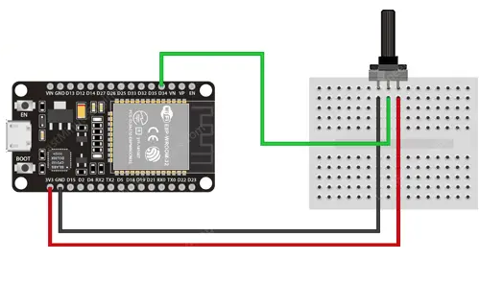

Source Code:
#define AN_Pot1 35
#define FILTER_LEN 15

uint32_t AN_Pot1_Buffer[FILTER_LEN] = {0};
int AN_Pot1_i = 0;
int AN_Pot1_Raw = 0;
int AN_Pot1_Filtered = 0;

void setup()
{
Serial.begin(115200);
}

void loop()
{
AN_Pot1_Raw = analogRead(AN_Pot1);
AN_Pot1_Filtered = readADC_Avg(AN_Pot1_Raw);
Serial.print(AN_Pot1_Raw); // Print Raw Reading
Serial.print(','); // Comma Separator
Serial.println(AN_Pot1_Filtered); // Print Filtered Output
delay(1000);
}

uint32_t readADC_Avg(int ADC_Raw)
{
int i = 0;
uint32_t Sum = 0;

AN_Pot1_Buffer[AN_Pot1_i++] = ADC_Raw;
if(AN_Pot1_i == FILTER_LEN)
{
AN_Pot1_i = 0;
}
for(i=0; i<FILTER_LEN; i++)
{
Sum += AN_Pot1_Buffer[i];
}
return (Sum/FILTER_LEN);
}

10.Observation of Analog output from ESP 32(Skill).

Mydaq –AI -0+ connect to Gpio16,0- to ground
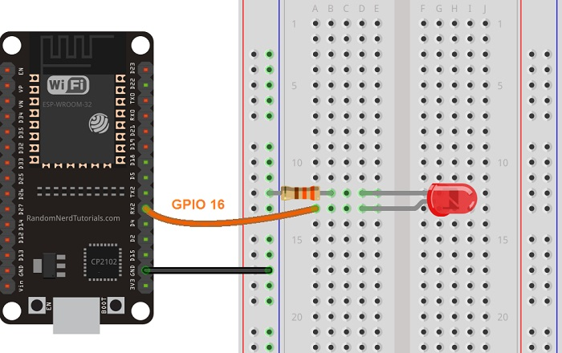

Code:
// the number of the LED pin
const int ledPin = 16; // 16 corresponds to GPIO16

// setting PWM properties
const int freq = 5000;
const int resolution = 8;

void setup(){
// configure LED PWM
ledcAttach(ledPin, freq, resolution);

// if you want to attach a specific channel, use the following instead
//ledcAttachChannel(ledPin, freq, resolution, 0);
}

void loop(){
// increase the LED brightness
for(int dutyCycle = 0; dutyCycle <= 255; dutyCycle++){
// changing the LED brightness with PWM
ledcWrite(ledPin, dutyCycle);
delay(15);
}

// decrease the LED brightness
for(int dutyCycle = 255; dutyCycle >= 0; dutyCycle--){
// changing the LED brightness with PWM
ledcWrite(ledPin, dutyCycle);
delay(15);
}
}

